

Research paper on Online auction system.

# Abstract:

An online auction system is a platform that allows users to buy and sell items through an auction-style process. It operates over the internet, allowing participants from anywhere in the world to participate in real-time. This system typically includes features such as item listings, bidding, secure payment processing, and user account management.

# 1. Introduction:

An online auction system is a platform that enables users to buy and sell goods and services through an auction process that takes place entirely over the internet. Bidders can place bids, view auction details, and bid history, and receive notifications of bidding activity in real-time. Sellers can list items for auction, set minimum prices, and manage their auction listings. Online auction systems typically use a bidding algorithm that determines the winner of the auction based on the highest bid and other factors such as the time remaining in the auction and the specific rules of the auction. Examples of online auction systems include eBay, Amazon Auction, and Yahoo! Auctions.

2. software:

|  |  |
| --- | --- |
| Serial no. | Tool |
| 1. | Bootstrap |
| 2. | CSS |
| 3. | JavaScript |
| 4. | Html |

3. Specifications.

|  |  |
| --- | --- |
| s.no | specification |
| 1. | Corei5 or higher |
| 2. | 8 Gb ram or 500ssd |
| 3. | Window 10 or higher |
| 4. | Graphic card |

4. working model:

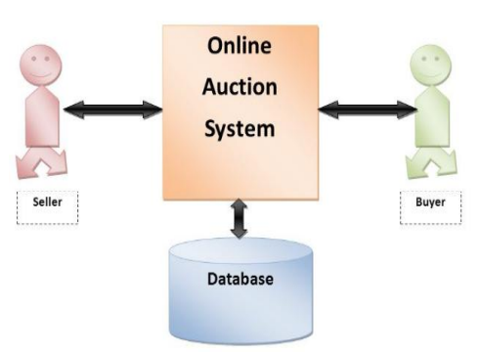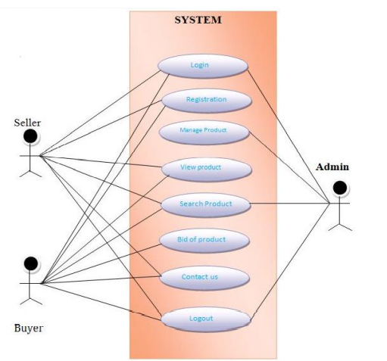

Block diagram. Use case diagram.

Use case diagram consist of use case and show interaction between them.

Points:

. Its show interaction between the use case and admin.

. To represent this system, it required from users' perspective.

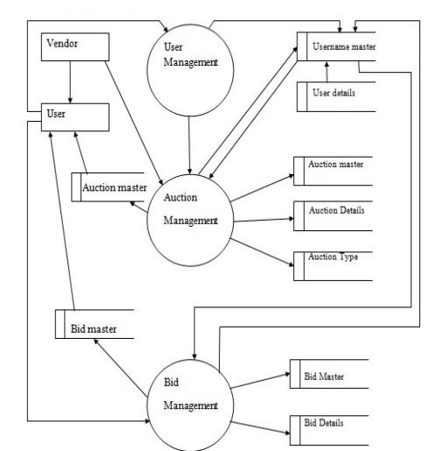 data flow system

The Entity-Relation (E-R) model is a graphical representation of entities and their relationships to each other, used in database design. It provides a visual representation of entities, attributes of entities, and relationships between entities, helping to identify the relationships between data objects. An E-R diagram is made up of entities, which are represented as boxes, and relationships, which are represented as lines connecting the boxes. Attributes, which describe properties of entities, are represented as ellipses connected to the entity boxes. The E-R model helps in designing the structure of a database, ensuring data is stored in an organized manner and relationships between data objects are properly defined.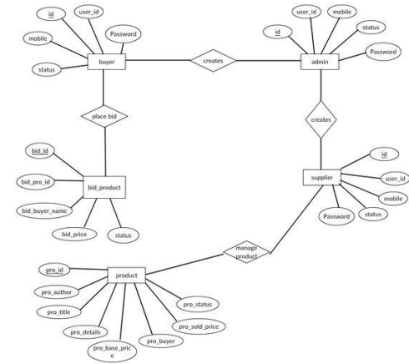

E-R diagram

## 5. Implementation:

When all procedure has been completely performed, then we move to practical to ensure that all stages are performed well.

5.1. system testing:

System Testing: The goal of the system testing process was to identify and correct any flaws in our project. It will be decided whether the software works as intended or not based on a set of test inputs, several explanations, and the results of these explanations.

5.2. unit testing:

When a unit has been constructed and thoroughly examined, unit testing can begin. An entire environment must be provided by a single module, which is different from the section we would need. The processes connected to other units that the test unit invokes.

6. Working:

6.1. Home page:

Snapshots that show how this online auction system functions and how it is simple to use will also be used to deliver information. Users must either create an account or log in before doing the first operation, which is uploading an auction.

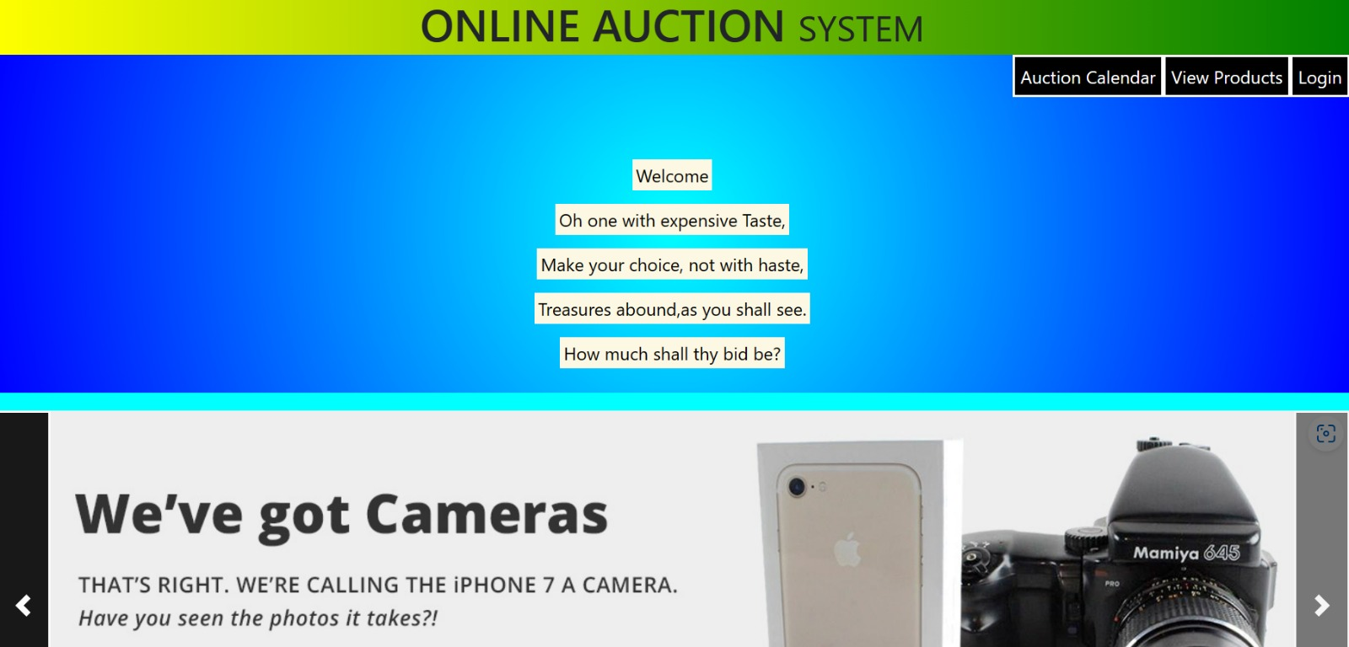

Home page

6.2. login page:

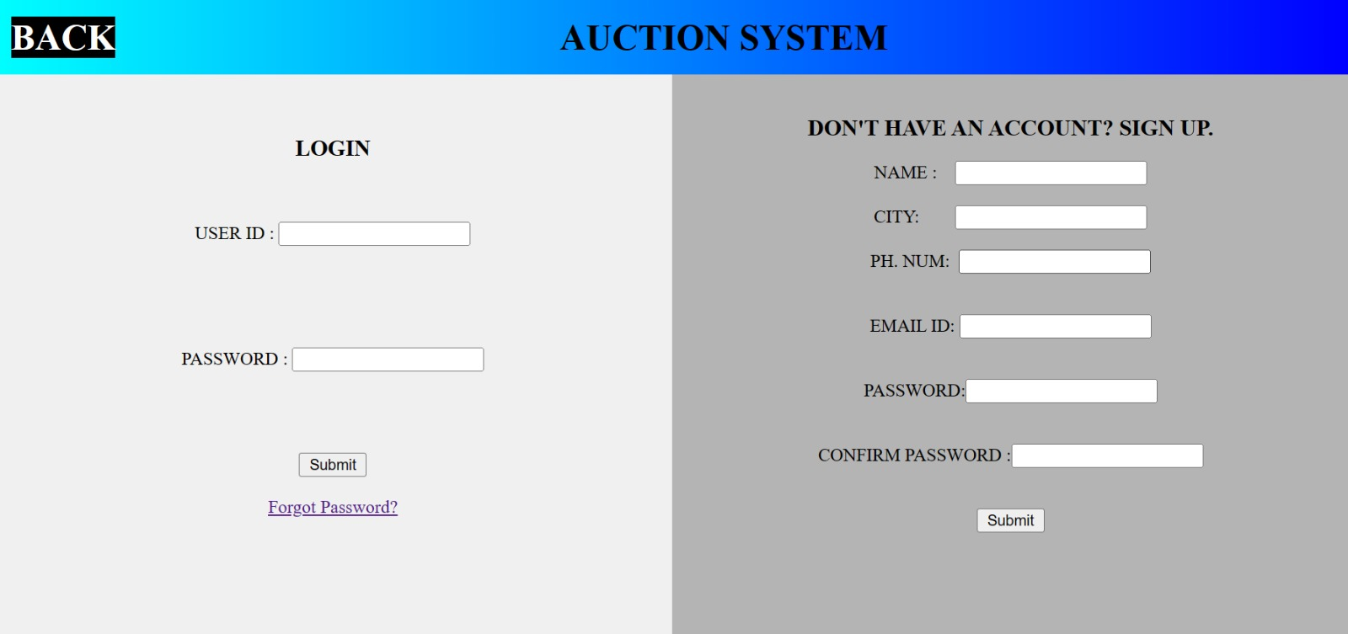 login page.

6.3. product pages:

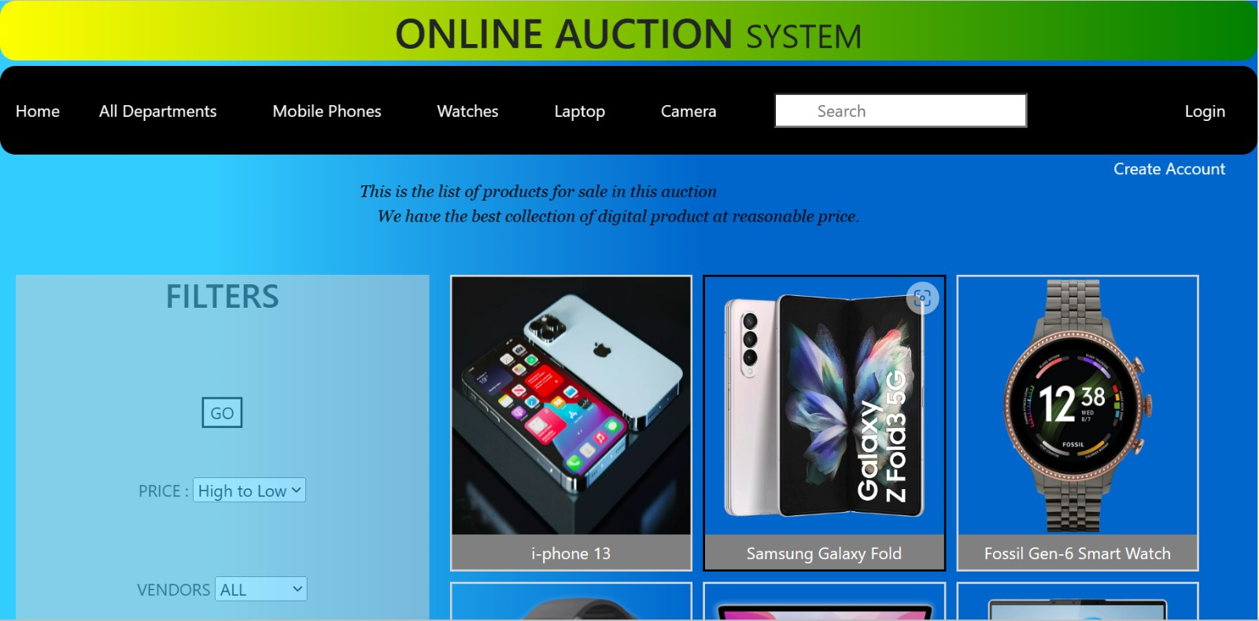

Product page.

7. application:

. Define the product or service being auctioned and the rules for bidding, such as the minimum bid increment and the deadline for bidding.

. Choose a technology stack, such as a web framework, database, and programming language, to build the platform.

. Design the user interface and create pages for listing items, making bids, and managing auctions.

. Implement user authentication and authorization to ensure the security of the platform and user information.

. Add features for managing auctions, such as automatic bidding, sending notifications to bidders, and calculating fees for sellers.

. Test the platform thoroughly to identify and fix any bugs or performance issues.

8. Conclusion:

Online auction systems are a convenient and efficient way for individuals and businesses to buy and sell goods and services over the internet. They offer advantages such as a wider audience, 24/7 availability, and often lower fees compared to traditional in-person auctions. However, online auctions also come with potential risks such as fraud and the challenge of verifying the authenticity and condition of items being sold. It is important to use caution and research the reputation of the platform and seller before participating in an online auction